Ideation PhaseDefine the Problem Statements

|  |  |
| --- | --- |
| Date | 25 September 2022 |
| Project Name | Project |
| Maximum Marks | 2 Marks |

**Customer Problem Statement :**

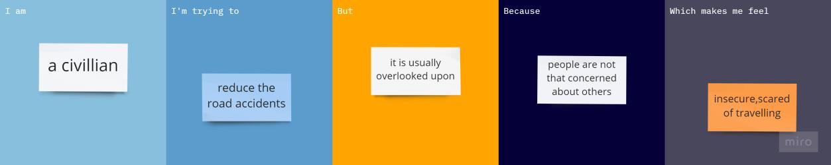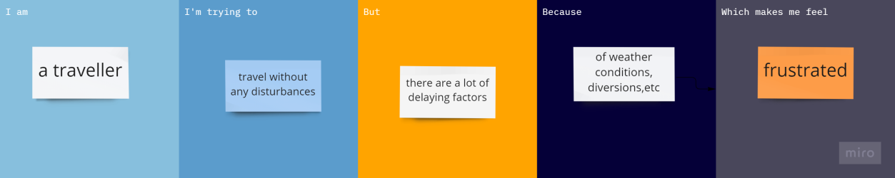

|  |  |  |  |  |  |
| --- | --- | --- | --- | --- | --- |
| **Problem Statement (PS)** | **I am (Customer)** | **I’m trying to** | **But** | **Because** | **Which makes me feel** |
| PS-1 | A civilian | Reduce the road accidents. | It is usually overlooked upon. | People are not that concerned  about accidents. | Insecure, scared to travel frequently. |
| PS-2 | A traveller | Travel without any minor inconvenience. | There are a lot of delaying factors. | Majorly because of weather conditions and other  issues . | Frustrated. |